Step 1: Place file in landing layer
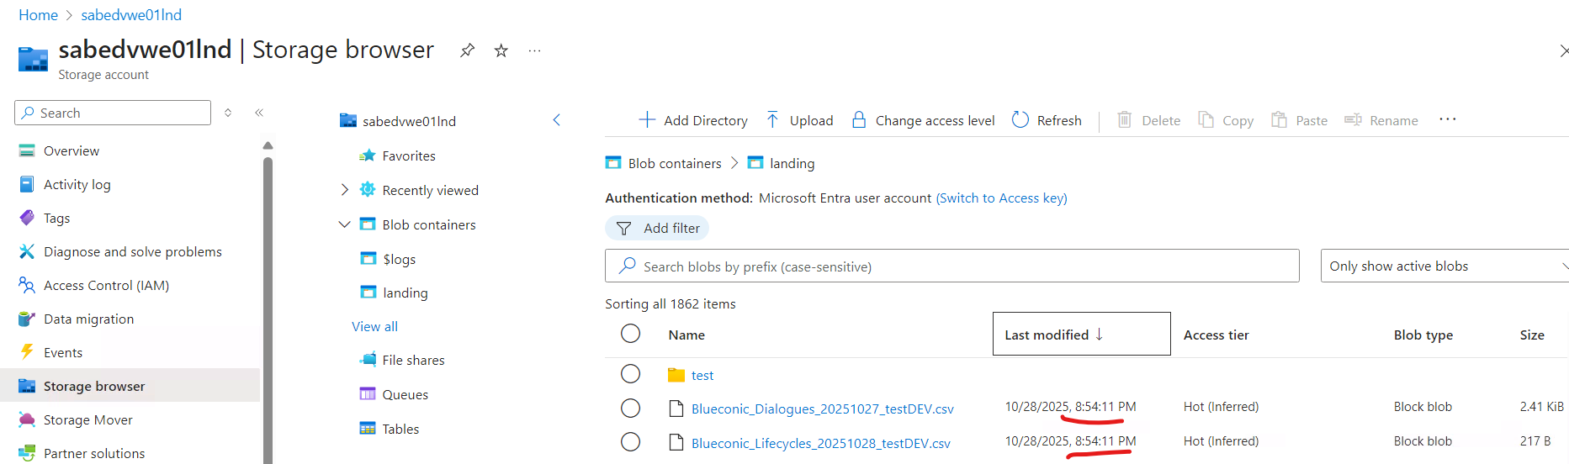
Step 2: Files should be in raw
Lifecycles
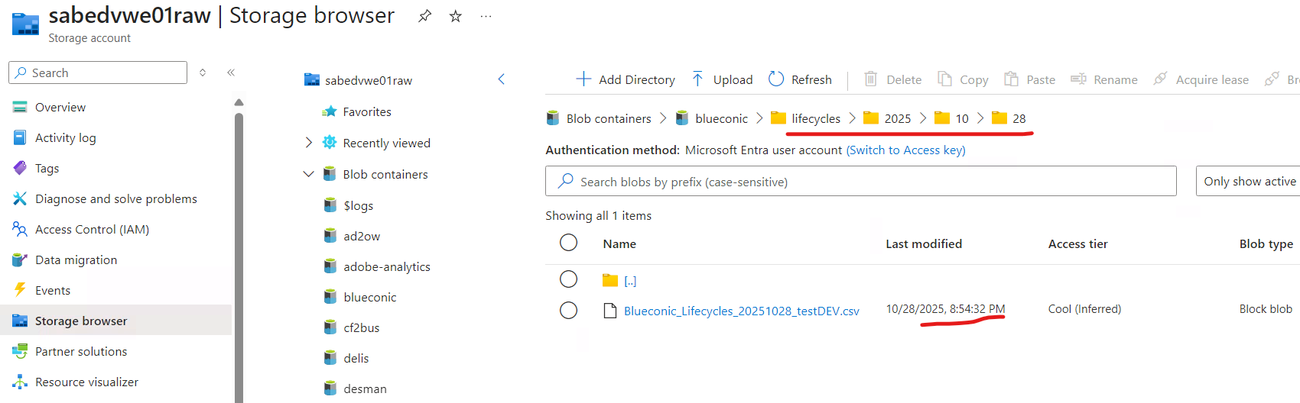
Dialogues
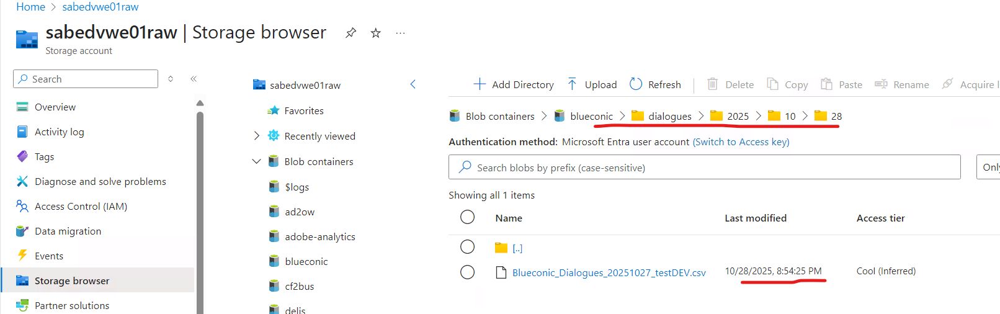
Step 3: Raw to clean trigger should be triggered
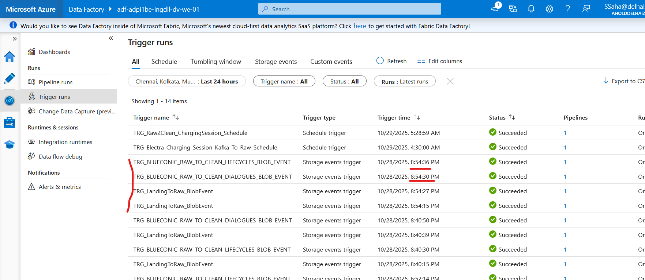
Step 4:data should be in clean layer
dialogues
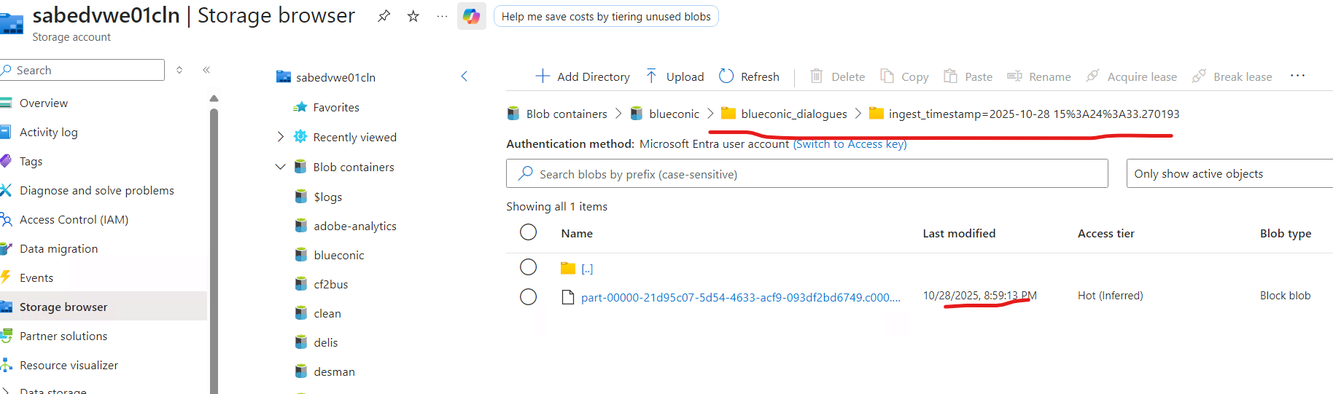
Lifecycles
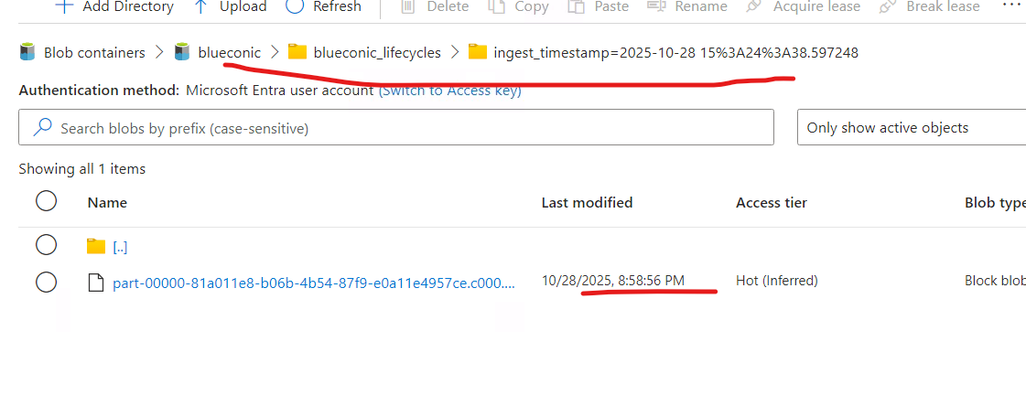
Pipleline DL_DATA_DATABRICKS
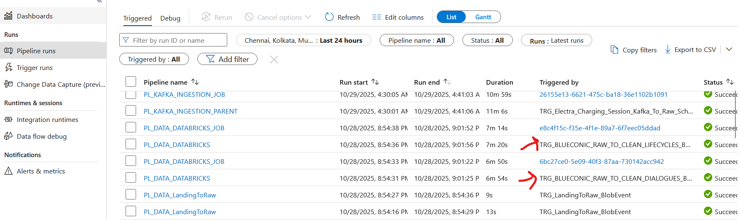
Data from unity catalog
